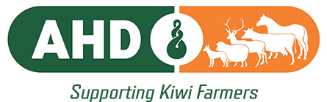 | 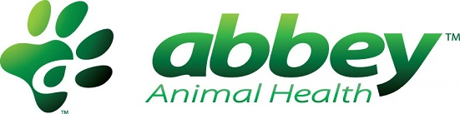

MEDIA RELEASE | For immediate release | 8 October 2026
Animal Health Direct announces new shareholding partnership with next stage of growth.
Animal Health Direct Ltd (AHD) is pleased to announce a change in its shareholding structure, with Abbey Animal Health acquiring a 50% shareholding in Animal Health Direct Ltd, effective 16 October 2026.
The partnership marks an exciting new chapter for AHD LTD and provides the business with an opportunity to further expand its product offering and strengthen its support for New Zealand farmers.
AHD Managing Director Richard Kettle says the partnership brings much more than investment to the business.
“Abbey brings access to new products, excellent manufacturing capability, strong R&D expertise and extensive experience gained from building a successful animal health business in Australia.
“Combining those capabilities with AHD’s established distribution network, warehousing, experienced team and strong relationships with New Zealand farmers makes this a great fit for both companies.”
AHD will continue to operate as it does today, with its focus firmly on its customers and on providing New Zealand farmers with quality, competitively priced animal health products. The partnership with Abbey will allow AHD to broaden its product range and introduce new options to the New Zealand market.
“Our focus has always been on supporting Kiwi farmers and helping them manage their animal health costs without compromising on quality or performance,” says Richard.
“Having Abbey as a partner gives us the opportunity to take that even further, with access to new products and capabilities that will ultimately provide more choice for New Zealand farmers.”

There will be no operational or staff changes as a result of the new shareholding. AHD will continue to operate from its Hastings head office at 2 Tumu Way, as well as its warehouse in Omakau, South Otago.
The business will also continue to invest in its people, with plans to expand its field sales team as new products are introduced to the New Zealand market.

“It really is an exciting time for AHD,” says Richard. “We have built a strong business over the past 25 years, and this partnership gives us the opportunity to build on that foundation and continue growing.”

About Abbey Animal Health
For further information on Abbey Animal Health and its investment in Animal Health Direct, please refer to Abbey Animal Health’s accompanying press release.

Contact
Richard D Kettle
Managing Director
Animal Health Direct Ltd
richard@ahdltd.co.nz

